1. Largest Number :
#CODE:
import java.util.*;

class Solution {
public String largestNumber(int[] nums) {

String[] arr = new String[nums.length];

// Convert integers to strings
for (int i = 0; i < nums.length; i++) {
arr[i] = String.valueOf(nums[i]);
}

// Custom sorting
Arrays.sort(arr, (a, b) -> (b + a).compareTo(a + b));

// If all numbers are 0
if (arr[0].equals("0")) {
return "0";
}

// Build the answer
StringBuilder result = new StringBuilder();

for (String s : arr) {
result.append(s);
}

return result.toString();
}
}

OUTPUT:
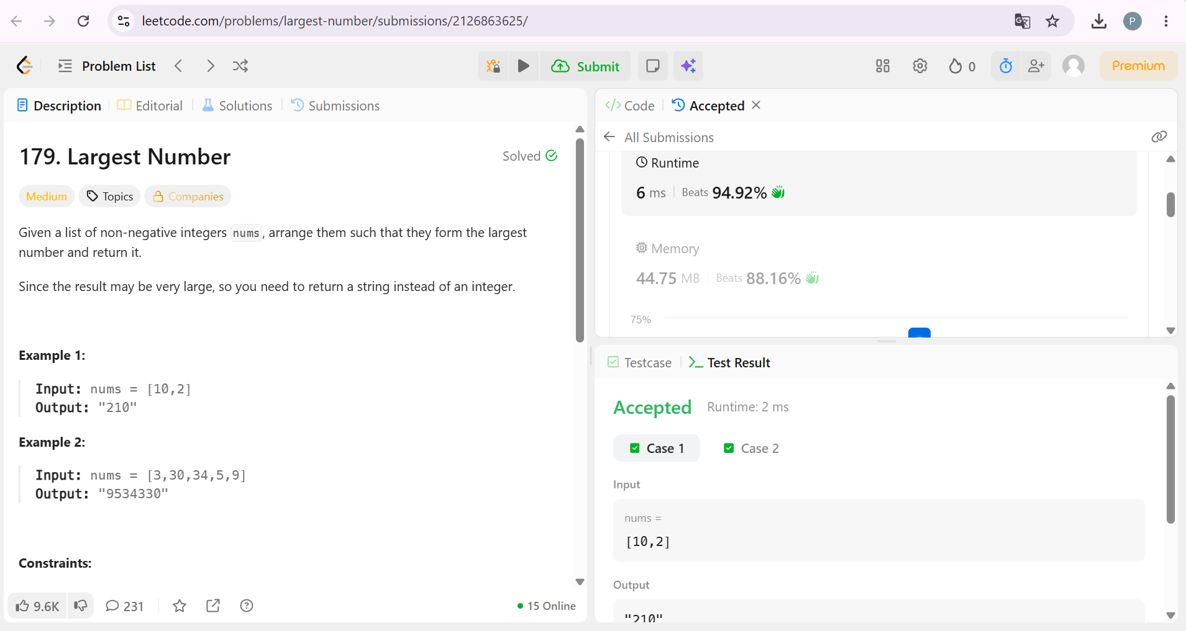

2. Java Comparator :
#CODE:
import java.util.*;

class Player {
String name;
int score;

Player(String name, int score) {
this.name = name;
this.score = score;
}
}

class Checker implements Comparator<Player> {

@Override
public int compare(Player a, Player b) {

// Higher score first
if (a.score != b.score) {
return b.score - a.score;
}

// Same score -> alphabetical order
return a.name.compareTo(b.name);
}
}

public class Solution {

public static void main(String[] args) {

Scanner sc = new Scanner(System.in);

int n = sc.nextInt();

Player[] players = new Player[n];

for (int i = 0; i < n; i++) {
String name = sc.next();
int score = sc.nextInt();

players[i] = new Player(name, score);
}

Arrays.sort(players, new Checker());

for (Player p : players) {
System.out.println(p.name + " " + p.score);
}

sc.close();
}
}

OUTPUT:
